**ARRAY**

***SOURCE CODE:***

<!DOCTYPE html>

<html lang="en">

<head>

<meta charset="UTF-8">

<meta http-equiv="X-UA-Compatible" content="IE=edge">

<meta name="viewport" content="width=device-width, initial-scale=1.0">

<title>Array in JS</title>

</head>

<style>body{

background-color: pink;

}

</style>

<body>

<h3>Subjects</h3>

<p>Here,[subjects.length] is a predefined datatype which calculates the length value from 1 whereas array takes a

value from 0 like subjects[0],subjects[1],etc

</p>

<script>

var subjects=["English","Tamil","Maths","Biology","Physics","Chemistry","Computer"];

document.write(subjects[1]);

document.write("<br>");

document.write(subjects[2]);

document.write("<br>");

document.write(subjects[5]);

document.write("<br>");

document.write(subjects[subjects.length-1]);

document.write("<br>");

document.write("<br>");

for(var i=0;i<=6;i++)

{

document.write(subjects[i]+"<br>");

}

document.write("<br>");

for(var i=6;i>=0;i--)

{

document.write(subjects[i]+"<br>");

}

document.write("<br>");

</script>

</body>

</html>

***OUTPUT:***

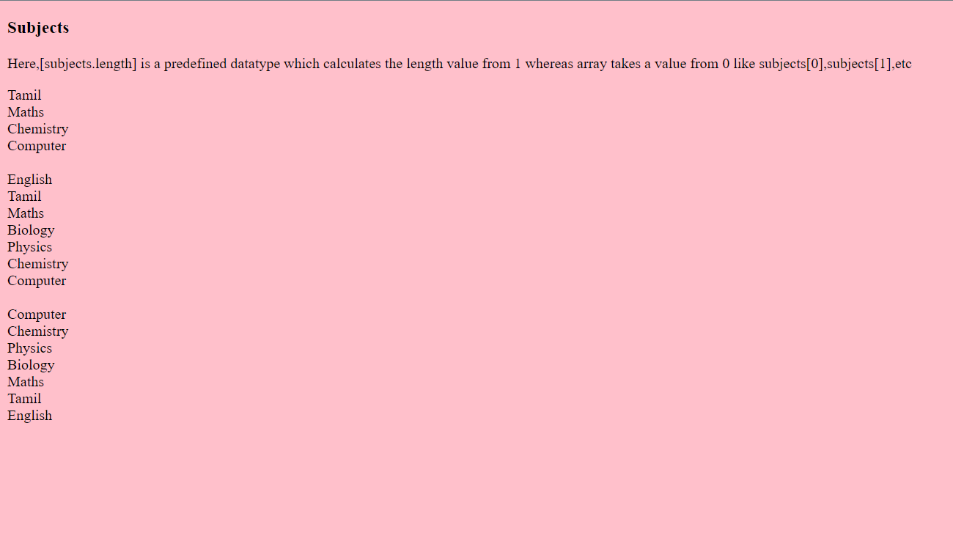

**ARRAY METHODS**

***SOURCE CODE:***

<!DOCTYPE html>

<html>

<head>

<title>Array Methods</title>

</head>

<body>

<h3>TYPES OF METHODS</h3>

<script>

var anime = ["Shounen", "Slice of Life", "Demon Slayer", "Isekai", "Naruto"];

var favanime="Death Note";

var fruits=["Apple","Orange","Apple"];

document.write("The Splice method");

document.write("<br>");

document.write(anime.splice(0,4));

document.write("<br>");

document.write("The Slice method");

document.write("<br>");

document.write(favanime.slice(0,5));

document.write("<br>");

document.write("The Delete method");

document.write("<br>");

document.write(anime.delete(2,"Death Note"));

document.write("<br>");

document.write("The Join method");

document.write("<br>");

document.write(anime.join("-"));

document.write("<br>");

document.write("The concatination of the anime names is " + anime.concat(favanime));

document.write("<br>");

document.write("The position of the given anime is " + anime.indexOf("Isekai"));

document.write("<br>");

document.write("The position of the given fruit is " + fruits.lastIndexOf("Apple"));

document.write("<br>");

</script>

</body>

</html>

***OUTPUT:***

